|  |  |  |  |  |  |  |  |  |  |  |  |
| --- | --- | --- | --- | --- | --- | --- | --- | --- | --- | --- | --- |
|  |  |  |  |  |  |  |  |  |  |  |  |
|  |  | | | **Protokół zmiany mikrokontrolera w płytce obsługującej czujnik US** | | | | | | Data wystawienia: | |
|  |  | |
|  | Doc# |  |
|  | Nr wniosku NCBR: | | POIR.01.01.01-00-0196/19 | | | Nazwa projektu: | | Smart Yacht |
|  | Rozpoczęcie testów: | |  | | Zakończenie testów: | |  | |

#### Założenia

Na rynku zabrakło mikrokontrolera STM32L443RCT, pojawiła się konieczność zastąpienia go innym. Na stanie magazynowy pozostało kilkadziesiąt mikrokontrolerów STM32L433RBT6P, zatem projekt został przygotowany pod owe.

#### **Zmiany wprowadzone w schemacie**

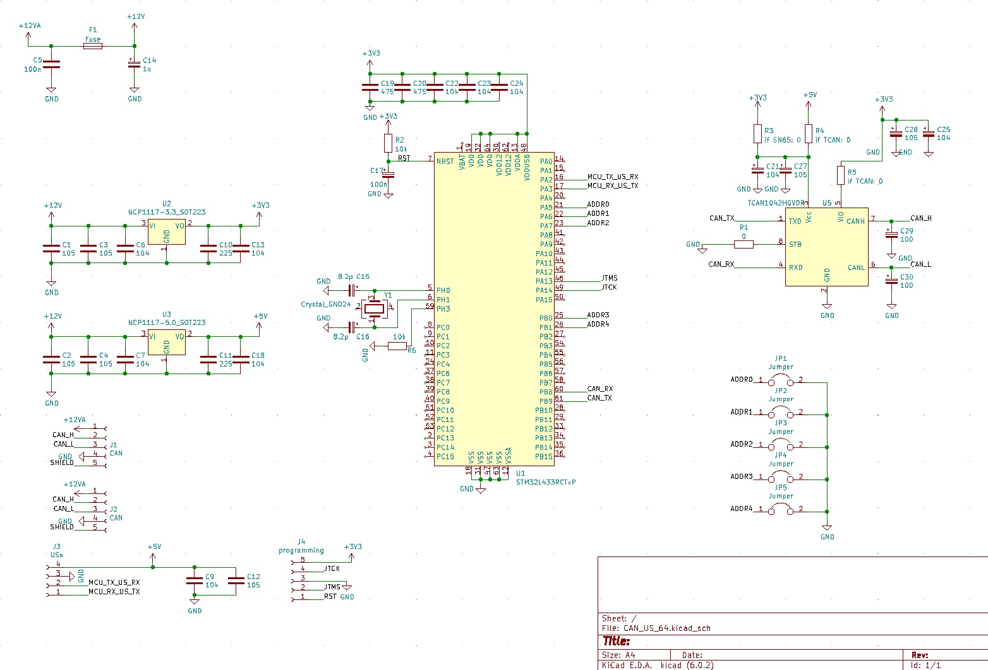Figura 1: Schemat płytki CAN_US_64 v1.1

-Mikrokontroler wymieniony na STM32L433RBT6p

-Zmodyfikowane połaczenia mikrokontrolera

-Schemat przygotowany również pod zastosowanie alternatywnego transceivera CAN, model SN65HVD230

#### Zmiany wprowadzone w projekcie PCB

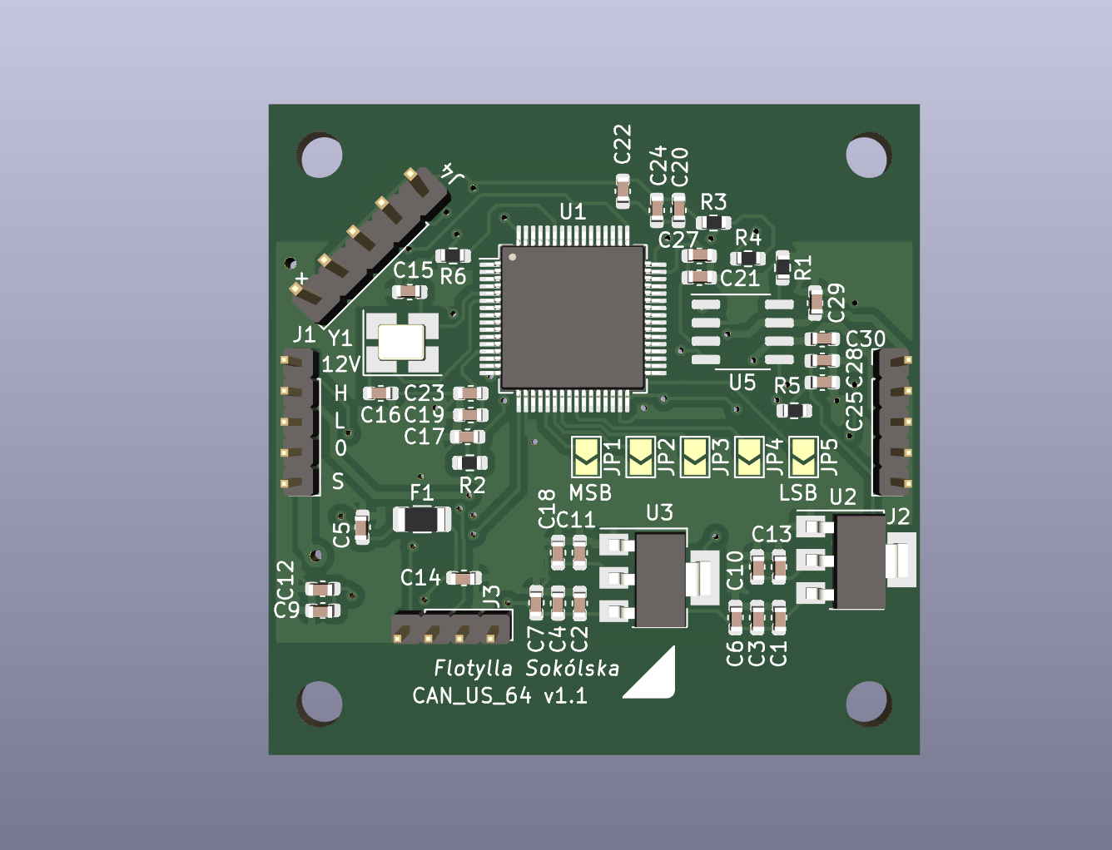Figura 2: CAN_US_64 v1.1- PCB

Płytka jest wzorowana na poprzedniej, CAN_US v2.0. Ma ten sam rozmiar, oraz takie samo rozłożenie złącz oraz otworów montażowych. Zworki zostały wymienione na lutowane.

#### **Zmiany wprowadzone w programie**

Treść pliku głównego:

**/* USER CODE BEGIN Header */**

/**

******************************************************************************

* @file : main.c

* @brief : Main program body

******************************************************************************

* @attention

*

* Copyright (c) 2022 STMicroelectronics.

* All rights reserved.

*

* This software is licensed under terms that can be found in the LICENSE file

* in the root directory of this software component.

* If no LICENSE file comes with this software, it is provided AS-IS.

*

******************************************************************************

*/

/* USER CODE END Header */

/* Includes ------------------------------------------------------------------*/

**#include** "main.h"

/* Private includes ----------------------------------------------------------*/

/* USER CODE BEGIN Includes */

/* USER CODE END Includes */

/* Private typedef -----------------------------------------------------------*/

/* USER CODE BEGIN PTD */

/* USER CODE END PTD */

/* Private define ------------------------------------------------------------*/

/* USER CODE BEGIN PD */

/* USER CODE END PD */

/* Private macro -------------------------------------------------------------*/

/* USER CODE BEGIN PM */

/* USER CODE END PM */

/* Private variables ---------------------------------------------------------*/

**CAN_HandleTypeDef** hcan1;

**TIM_HandleTypeDef** htim6;

**UART_HandleTypeDef** huart2;

/* USER CODE BEGIN PV */

**CAN_FilterTypeDef** canFilterConfig;

**CAN_TxHeaderTypeDef** pHeader;

**CAN_RxHeaderTypeDef** canRxHeader;

**CAN_TxHeaderTypeDef** canTxHeader;

**uint8_t** Data;

**uint8_t** uartUsRx;

**GPIO_InitTypeDef** gpio;

**uint8_t** canRxData[8];

**uint8_t** canTxData[8];

**union** **Data2Bytes**{

**uint8_t** bytes [2];

**uint16_t** data;

}data2Bytes;

**uint16_t** canId;

**uint32_t** TxMailbox;

**typedef** **struct**{

**uint8_t** data[4];

**uint16_t** distance;

**uint8_t** counter;

**uint8_t** frameStarted;

}**Us**;

**Us** us;

/* USER CODE END PV */

/* Private function prototypes -----------------------------------------------*/

**void** **SystemClock_Config**(**void**);

**static** **void** **MX_GPIO_Init**(**void**);

**static** **void** **MX_CAN1_Init**(**void**);

**static** **void** **MX_USART2_UART_Init**(**void**);

**static** **void** **MX_TIM6_Init**(**void**);

/* USER CODE BEGIN PFP */

**void** **setCanAdress**(**void**);

/* USER CODE END PFP */

/* Private user code ---------------------------------------------------------*/

/* USER CODE BEGIN 0 */

/* USER CODE END 0 */

/**

* @brief The application entry point.

* @retval int

*/

**int** **main**(**void**)

{

/* USER CODE BEGIN 1 */

/* USER CODE END 1 */

/* MCU Configuration--------------------------------------------------------*/

/* Reset of all peripherals, Initializes the Flash interface and the Systick. */

**HAL_Init**();

/* USER CODE BEGIN Init */

/* USER CODE END Init */

/* Configure the system clock */

**SystemClock_Config**();

/* USER CODE BEGIN SysInit */

/* USER CODE END SysInit */

/* Initialize all configured peripherals */

**MX_GPIO_Init**();

**MX_CAN1_Init**();

**MX_USART2_UART_Init**();

**MX_TIM6_Init**();

/* USER CODE BEGIN 2 */

**HAL_UART_Init**(&huart2);

**HAL_UART_Receive_IT**(&huart2, &uartUsRx, 1);

**HAL_CAN_Start**(&hcan1);

canId = 200;

**setCanAdress**();

//change interval of TIM6 interrupt depending on sensor number. This will take it unsynchronized

htim6.Init.Prescaler = 2900 + (canTxHeader.StdId-1000);

**if** (**HAL_TIM_Base_Init**(&htim6) != *HAL_OK*) {

**Error_Handler**();

}

**HAL_TIM_Base_Start_IT**(&htim6);

/* USER CODE END 2 */

/* Infinite loop */

/* USER CODE BEGIN WHILE */

**while** (1)

{

**setCanAdress**();

/* USER CODE END WHILE */

/* USER CODE BEGIN 3 */

}

/* USER CODE END 3 */

}

/**

* @brief System Clock Configuration

* @retval None

*/

**void** **SystemClock_Config**(**void**)

{

**RCC_OscInitTypeDef** RCC_OscInitStruct = {0};

**RCC_ClkInitTypeDef** RCC_ClkInitStruct = {0};

/** Configure the main internal regulator output voltage

*/

**if** (**HAL_PWREx_ControlVoltageScaling**(PWR_REGULATOR_VOLTAGE_SCALE1) != *HAL_OK*)

{

**Error_Handler**();

}

/** Initializes the RCC Oscillators according to the specified parameters

* in the RCC_OscInitTypeDef structure.

*/

RCC_OscInitStruct.OscillatorType = RCC_OSCILLATORTYPE_HSE;

RCC_OscInitStruct.HSEState = RCC_HSE_ON;

RCC_OscInitStruct.PLL.PLLState = RCC_PLL_ON;

RCC_OscInitStruct.PLL.PLLSource = RCC_PLLSOURCE_HSE;

RCC_OscInitStruct.PLL.PLLM = 1;

RCC_OscInitStruct.PLL.PLLN = 20;

RCC_OscInitStruct.PLL.PLLP = RCC_PLLP_DIV7;

RCC_OscInitStruct.PLL.PLLQ = RCC_PLLQ_DIV2;

RCC_OscInitStruct.PLL.PLLR = RCC_PLLR_DIV2;

**if** (**HAL_RCC_OscConfig**(&RCC_OscInitStruct) != *HAL_OK*)

{

**Error_Handler**();

}

/** Initializes the CPU, AHB and APB buses clocks

*/

RCC_ClkInitStruct.ClockType = RCC_CLOCKTYPE_HCLK|RCC_CLOCKTYPE_SYSCLK

|RCC_CLOCKTYPE_PCLK1|RCC_CLOCKTYPE_PCLK2;

RCC_ClkInitStruct.SYSCLKSource = RCC_SYSCLKSOURCE_PLLCLK;

RCC_ClkInitStruct.AHBCLKDivider = RCC_SYSCLK_DIV1;

RCC_ClkInitStruct.APB1CLKDivider = RCC_HCLK_DIV1;

RCC_ClkInitStruct.APB2CLKDivider = RCC_HCLK_DIV1;

**if** (**HAL_RCC_ClockConfig**(&RCC_ClkInitStruct, FLASH_LATENCY_4) != *HAL_OK*)

{

**Error_Handler**();

}

}

/**

* @brief CAN1 Initialization Function

* @param None

* @retval None

*/

**static** **void** **MX_CAN1_Init**(**void**)

{

/* USER CODE BEGIN CAN1_Init 0 */

/* USER CODE END CAN1_Init 0 */

/* USER CODE BEGIN CAN1_Init 1 */

/* USER CODE END CAN1_Init 1 */

hcan1.Instance = CAN1;

hcan1.Init.Prescaler = 40;

hcan1.Init.Mode = CAN_MODE_NORMAL;

hcan1.Init.SyncJumpWidth = CAN_SJW_1TQ;

hcan1.Init.TimeSeg1 = CAN_BS1_13TQ;

hcan1.Init.TimeSeg2 = CAN_BS2_2TQ;

hcan1.Init.TimeTriggeredMode = *DISABLE*;

hcan1.Init.AutoBusOff = *DISABLE*;

hcan1.Init.AutoWakeUp = *ENABLE*;

hcan1.Init.AutoRetransmission = *DISABLE*;

hcan1.Init.ReceiveFifoLocked = *DISABLE*;

hcan1.Init.TransmitFifoPriority = *DISABLE*;

**if** (**HAL_CAN_Init**(&hcan1) != *HAL_OK*)

{

**Error_Handler**();

}

/* USER CODE BEGIN CAN1_Init 2 */

canFilterConfig.FilterMode = CAN_FILTERMODE_IDMASK;

canFilterConfig.FilterScale = CAN_FILTERSCALE_32BIT;

canFilterConfig.FilterIdHigh = 210;

canFilterConfig.FilterIdLow = 200;

canFilterConfig.FilterMaskIdHigh = 0x0000;

canFilterConfig.FilterMaskIdLow = 0x0000;

canFilterConfig.FilterFIFOAssignment = CAN_RX_FIFO0;

canFilterConfig.FilterActivation = *ENABLE*;

canFilterConfig.FilterBank = 1;

**HAL_CAN_ConfigFilter**(&hcan1, &canFilterConfig);

canFilterConfig.FilterIdHigh = 0;

canFilterConfig.FilterIdLow = 0;

canFilterConfig.FilterBank = 2;

**HAL_CAN_ConfigFilter**(&hcan1, &canFilterConfig);

**HAL_CAN_Start**(&hcan1);

**if** (**HAL_CAN_ActivateNotification**(&hcan1, CAN_IT_RX_FIFO0_MSG_PENDING)

!= *HAL_OK*) {

/* Notification Error */

**Error_Handler**();

}

canTxHeader.DLC = 1; //give message size of 1 byte

canTxHeader.IDE = CAN_ID_STD; //set identifier to standard

canTxHeader.RTR = CAN_RTR_DATA; //set data type to remote transmission request?

canTxHeader.StdId = 200;

canTxHeader.ExtId = 0x00;

/* USER CODE END CAN1_Init 2 */

}

/**

* @brief TIM6 Initialization Function

* @param None

* @retval None

*/

**static** **void** **MX_TIM6_Init**(**void**)

{

/* USER CODE BEGIN TIM6_Init 0 */

/* USER CODE END TIM6_Init 0 */

**TIM_MasterConfigTypeDef** sMasterConfig = {0};

/* USER CODE BEGIN TIM6_Init 1 */

/* USER CODE END TIM6_Init 1 */

htim6.Instance = TIM6;

htim6.Init.Prescaler = 2999;

htim6.Init.CounterMode = TIM_COUNTERMODE_UP;

htim6.Init.Period = 2665;

htim6.Init.AutoReloadPreload = TIM_AUTORELOAD_PRELOAD_DISABLE;

**if** (**HAL_TIM_Base_Init**(&htim6) != *HAL_OK*)

{

**Error_Handler**();

}

sMasterConfig.MasterOutputTrigger = TIM_TRGO_RESET;

sMasterConfig.MasterSlaveMode = TIM_MASTERSLAVEMODE_DISABLE;

**if** (**HAL_TIMEx_MasterConfigSynchronization**(&htim6, &sMasterConfig) != *HAL_OK*)

{

**Error_Handler**();

}

/* USER CODE BEGIN TIM6_Init 2 */

/* USER CODE END TIM6_Init 2 */

}

/**

* @brief USART2 Initialization Function

* @param None

* @retval None

*/

**static** **void** **MX_USART2_UART_Init**(**void**)

{

/* USER CODE BEGIN USART2_Init 0 */

/* USER CODE END USART2_Init 0 */

/* USER CODE BEGIN USART2_Init 1 */

/* USER CODE END USART2_Init 1 */

huart2.Instance = USART2;

huart2.Init.BaudRate = 9600;

huart2.Init.WordLength = UART_WORDLENGTH_8B;

huart2.Init.StopBits = UART_STOPBITS_1;

huart2.Init.Parity = UART_PARITY_NONE;

huart2.Init.Mode = UART_MODE_RX;

huart2.Init.HwFlowCtl = UART_HWCONTROL_NONE;

huart2.Init.OverSampling = UART_OVERSAMPLING_16;

huart2.Init.OneBitSampling = UART_ONE_BIT_SAMPLE_DISABLE;

huart2.AdvancedInit.AdvFeatureInit = UART_ADVFEATURE_NO_INIT;

**if** (**HAL_UART_Init**(&huart2) != *HAL_OK*)

{

**Error_Handler**();

}

/* USER CODE BEGIN USART2_Init 2 */

/* USER CODE END USART2_Init 2 */

}

/**

* @brief GPIO Initialization Function

* @param None

* @retval None

*/

**static** **void** **MX_GPIO_Init**(**void**)

{

**GPIO_InitTypeDef** GPIO_InitStruct = {0};

/* GPIO Ports Clock Enable */

__HAL_RCC_GPIOH_CLK_ENABLE();

__HAL_RCC_GPIOA_CLK_ENABLE();

__HAL_RCC_GPIOB_CLK_ENABLE();

/*Configure GPIO pins : ADDR0_Pin ADDR1_Pin ADDR2_Pin */

GPIO_InitStruct.Pin = ADDR0_Pin|ADDR1_Pin|ADDR2_Pin;

GPIO_InitStruct.Mode = GPIO_MODE_INPUT;

GPIO_InitStruct.Pull = GPIO_PULLUP;

**HAL_GPIO_Init**(GPIOA, &GPIO_InitStruct);

/*Configure GPIO pins : ADDR3_Pin ADDR4_Pin */

GPIO_InitStruct.Pin = ADDR3_Pin|ADDR4_Pin;

GPIO_InitStruct.Mode = GPIO_MODE_INPUT;

GPIO_InitStruct.Pull = GPIO_PULLUP;

**HAL_GPIO_Init**(GPIOB, &GPIO_InitStruct);

}

/* USER CODE BEGIN 4 */

**void** **setCanAdress**(**void**) {

//od 200 co 10

//odczytaj zworki adresowe

**uint8_t** bit0 = **HAL_GPIO_ReadPin**(ADDR0_GPIO_Port, ADDR0_Pin);

**uint8_t** bit1 = **HAL_GPIO_ReadPin**(ADDR1_GPIO_Port, ADDR1_Pin);

**uint8_t** bit2 = **HAL_GPIO_ReadPin**(ADDR2_GPIO_Port, ADDR2_Pin);

**uint8_t** bit3 = **HAL_GPIO_ReadPin**(ADDR3_GPIO_Port, ADDR3_Pin);

**uint8_t** bit4 = **HAL_GPIO_ReadPin**(ADDR4_GPIO_Port, ADDR4_Pin);

**if** (bit0 == 1 && bit1 == 1 && bit2 == 1 && bit3 == 1 && bit4 == 1)

canId = 1010;

**else** **if** (bit0 == 1 && bit1 == 1 && bit2 == 1 && bit3 == 1 && bit4 == 0)

canId = 1020;

**else** **if** (bit0 == 1 && bit1 == 1 && bit2 == 1 && bit3 == 0 && bit4 == 1)

canId = 1030;

**else** **if** (bit0 == 1 && bit1 == 1 && bit2 == 1 && bit3 == 0 && bit4 == 0)

canId = 1040;

**else** **if** (bit0 == 1 && bit1 == 1 && bit2 == 0 && bit3 == 1 && bit4 == 1)

canId = 1050;

**else** **if** (bit0 == 1 && bit1 == 1 && bit2 == 0 && bit3 == 1 && bit4 == 0)

canId = 1060;

**else** **if** (bit0 == 1 && bit1 == 1 && bit2 == 0 && bit3 == 0 && bit4 == 1)

canId = 1070;

**else** **if** (bit0 == 1 && bit1 == 1 && bit2 == 0 && bit3 == 0 && bit4 == 0)

canId = 1080;

**else** **if** (bit0 == 1 && bit1 == 0 && bit2 == 1 && bit3 == 1 && bit4 == 1)

canId = 1090;

**else** **if** (bit0 == 1 && bit1 == 0 && bit2 == 1 && bit3 == 1 && bit4 == 0)

canId = 1100;

**else** **if** (bit0 == 1 && bit1 == 0 && bit2 == 1 && bit3 == 0 && bit4 == 1)

canId = 1110;

**else** **if** (bit0 == 1 && bit1 == 0 && bit2 == 1 && bit3 == 0 && bit4 == 0)

canId = 1120;

**else** **if** (bit0 == 1 && bit1 == 0 && bit2 == 0 && bit3 == 1 && bit4 == 1)

canId = 1130;

**else** **if** (bit0 == 1 && bit1 == 0 && bit2 == 0 && bit3 == 1 && bit4 == 0)

canId = 1140;

**else** **if** (bit0 == 1 && bit1 == 0 && bit2 == 0 && bit3 == 0 && bit4 == 1)

canId = 1150;

//ustaw adres czujnika

canTxHeader.StdId = canId;

}

**void** **HAL_UART_RxCpltCallback**(**UART_HandleTypeDef** *huart) {

**if** (huart == &huart2) { //odczyt danych z czujnka

**if** (uartUsRx == 0xff || us.frameStarted == 0) { //&&

us.data[0] = uartUsRx;

us.counter = 0;

us.frameStarted = 1;

}

**if** (us.frameStarted == 1) {

us.data[us.counter] = uartUsRx;

**if** (us.counter == 3) {

us.frameStarted = 0;

**int** sum = (us.data[0] + us.data[1] + us.data[2]) & 0x00FF;

**if** (sum == us.data[3]) {

us.distance = (us.data[1] << 8) + us.data[2];

**if** (us.distance < 280 && us.distance >= 255) {

us.distance = 280;

}

**if** (us.distance > 7500 || us.distance <= 255) {

us.distance = 7500;

}

canTxHeader.StdId = canId;

canTxHeader.DLC = 2;

canTxData[0] = us.distance >> 8;

canTxData[1] = us.distance;

}

} **else** {

us.counter++;

}

}

**HAL_UART_Receive_IT**(&huart2, &uartUsRx, 1);

}

}

**void** **HAL_TIM_PeriodElapsedCallback**(**TIM_HandleTypeDef** *htim) {

**if** (htim->Instance == TIM6) {

**HAL_CAN_AddTxMessage**(&hcan1, &canTxHeader, canTxData, &TxMailbox);

}

}

/* USER CODE END 4 */

/**

* @brief This function is executed in case of error occurrence.

* @retval None

*/

**void** **Error_Handler**(**void**)

{

/* USER CODE BEGIN Error_Handler_Debug */

/* User can add his own implementation to report the HAL error return state */

**__disable_irq**();

**while** (1)

{

}

/* USER CODE END Error_Handler_Debug */

}

**#ifdef** USE_FULL_ASSERT

/**

* @brief Reports the name of the source file and the source line number

* where the assert_param error has occurred.

* @param file: pointer to the source file name

* @param line: assert_param error line source number

* @retval None

*/

**void** assert_failed(uint8_t *file, uint32_t line)

{

/* USER CODE BEGIN 6 */

/* User can add his own implementation to report the file name and line number,

ex: printf("Wrong parameters value: file %s on line %d\r\n", file, line) */

/* USER CODE END 6 */

}

**#endif** /* USE_FULL_ASSERT */

Program jest taki sam jak dla wersji CAN_US v2.0, jednak różni się konfiguracją pinów i mikrokontrolerem.

#### **Wnioski**

Układ został przetestowany, programuje się i działa poprawnie.

-

Wykonał: Bartosz Pracz